**Working with Arduino TCS-230 Color Detector Sensor**

Diagram

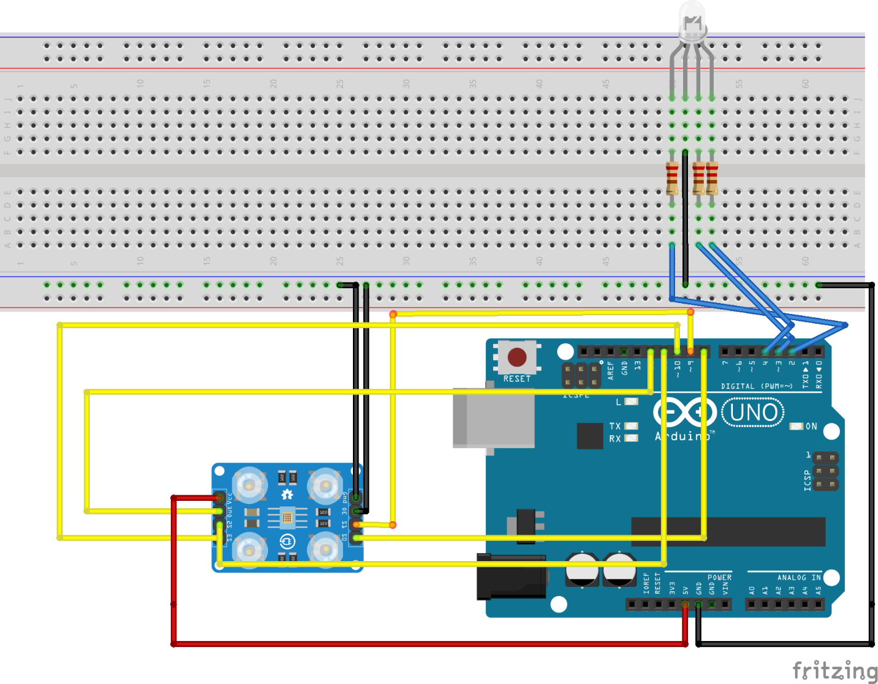

**Requirements**

* **3x1k ohm resistor**
* **Arduino UNO or MEGA**
* **TCS-230**
* **RGB LED common cathode here**
* **Breadboard**
* **Jumper wires**

**Working**

We are required to interface color sensor TCS-230 with Arduino. We will provide light source using RGB Led which works on PWM changes color according to settings in code. It is important to have resistor with RGB led otherwise it can fuse.

**Code Output**

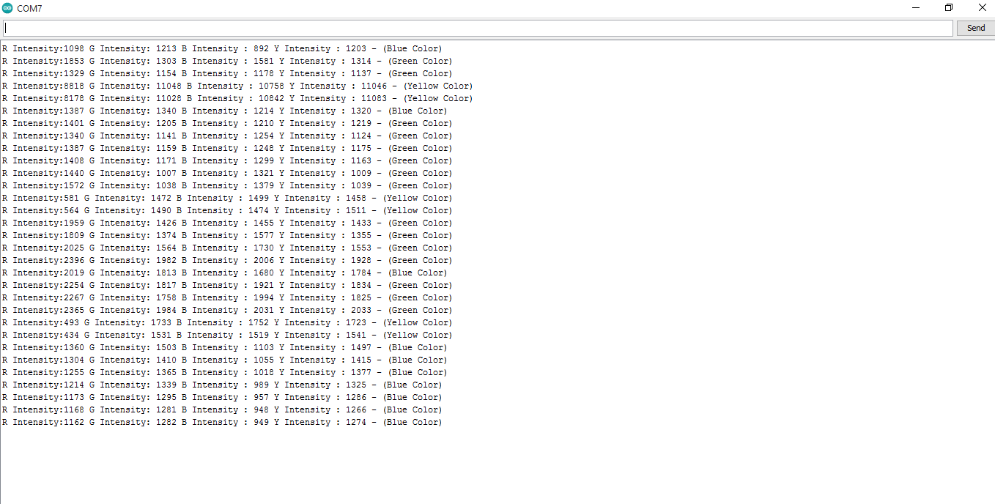

**Yellow color in RGB**

Yellow color is composed of Red and green. A code has been uploaded as TCS_230 yellow. It has a loop which changes brightness of both red and green to 255. When both these colors mix it makes a yellow. More colors can be added but user has to know its color mixing.